**CIA 1 – Component 1**

Register Number: 1740256

**Date:** 20/11/2017

--------------------------------------------------------------------------------------------

**Question 1**

**Aim** – To demonstrate the usage of sorting variables in SPSS with 2 examples.

**Procedure -**

1. Open SPSS software and choose any data file.
2. Click on variable view.
3. Click on data on the top menu and choose sort variables.
4. It shows the different variables which can be sorted in that data.
5. Choose columns because sorting cases is through columns.
6. Choose ascending or descending and click ok.   
   **NOTE** – If we want to save the newly sorted data to a new file, then check the box of save file with sorted data. Click on OK and save the file.
7. The columns are sorted.

**Calculations –**

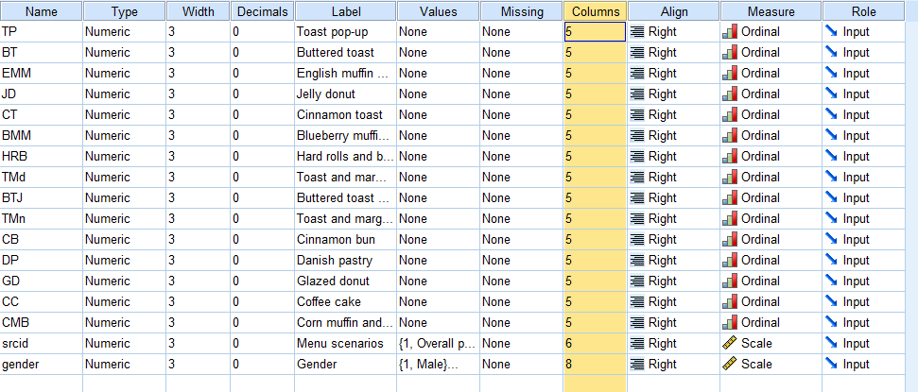

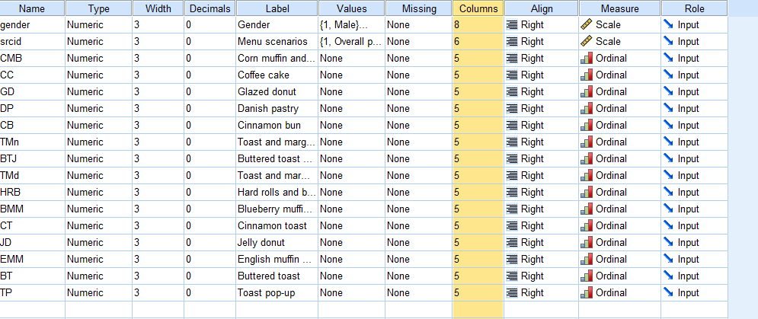

**Conclusion -**

The data set above is breakfast.sav have been sorted and sort variables are performed by sorting the columns in ascending and descending order.

--------------------------------------------------------------------------------------------